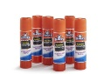**5th grade Classroom Supply List for 2024-2025**

**-Glue Sticks**

**-Colored Pencils**

**-Highlighters**

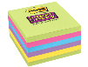**-Sticky Notes**

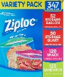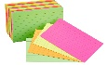**-Index Cards**

**-Gallon/Quart/Snack Ziploc Bags**

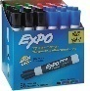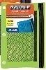**-Dry erase Expo markers**

# -3-ring Zipper Pencil Pouch w/Mesh Window

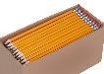**-Over the ear USB Headphones**

**-Pencils**

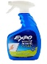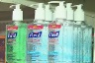**-Hand sanitizer (Non-Perfume)**

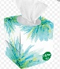**-Expo Spray**

**-Tissues**

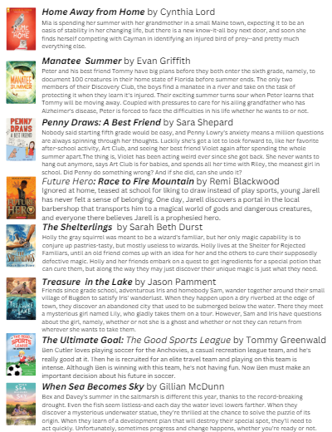**-Clorox Wipes** 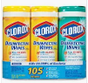

**-1 Sunshine State Reader Book**